*Comparative Analysis of Leading and Lagging Technical Indicators in the Indian Stock* Market

Pranav Bhavsar

TE IT/A

Thakur College of Engineering and

Technology, Mumbai

Mumbai, India

pranavbhavsr2003@gmail.com

Bharat Bohra

TE IT/A

Thakur College of Engineering and

Technology, Mumbai

Mumbai, India

[bharatbohra07@gmail.com](mailto:bharatbohra07@gmail.com)

**Abstract—** **This research paper delves into a comprehensive comparative analysis of leading and lagging technical indicators within the dynamic landscape of the Indian stock market. With a focus on evaluating their predictive potential, the study scrutinizes historical stock data to discern the efficacy of these indicators in forecasting price fluctuations. Through practical examples and in-depth examination, the paper endeavors to provide traders and investors with actionable insights to inform their decision-making processes**.

**By assessing the performance of these indicators across diverse market conditions, the study aims to facilitate the identification of the most reliable indicators for trading strategies. The comparative analysis sheds light on the strengths and weaknesses of leading and lagging indicators, offering valuable guidance for navigating the intricacies of the Indian stock market. Ultimately, this research aims to contribute to the enhancement of trading methodologies and the optimization of investment strategies amidst the ever-evolving landscape of financial markets.**

**Keywords— Indian stock market, technical analysis, leading indicators, lagging indicators, comparative analysis.**

1. INTRODUCTION

In the financial markets, technical analysis stands as a cornerstone methodology for predicting price movements and informing trading decisions. Rooted in the analysis of historical market data, technical analysis offers traders and investors a systematic approach to understanding market trends, identifying potential entry and exit points, and managing risk. Central to this methodology are technical indicators, which serve as invaluable tools in assessing market sentiment, momentum, and the strength of trends.

The Indian stock market, characterized by its dynamism, diversity, and volatility, presents a compelling landscape for the application and evaluation of technical indicators. As one of the fastest-growing economies globally, India's stock market attracts a broad spectrum of participants, from individual retail investors to institutional funds and foreign investors. Amidst this vibrant ecosystem, the efficacy of technical indicators in forecasting price movements assumes heightened significance, offering market participants valuable insights into potential trading opportunities and risk management strategies.

In this context, the present research endeavors to conduct a comprehensive comparative analysis of leading and lagging technical indicators within the Indian stock market. By scrutinizing the performance and predictive potential of these indicators, the study seeks to provide empirical evidence and practical insights to aid traders and investors in navigating the complexities of the Indian stock market landscape.

The significance of this research lies in its potential to bridge the gap between theoretical insights and practical application within the domain of technical analysis. While a plethora of literature exists on the subject, empirical studies focusing specifically on the Indian stock market context remain relatively sparse. By addressing this lacuna, the research aims to contribute to the body of knowledge surrounding technical analysis, particularly in the context of emerging and dynamic markets such as India.

Moreover, the findings of this study hold implications not only for individual traders and investors but also for financial institutions, regulatory bodies, and policymakers. In an era marked by technological advancements and increasing democratization of financial markets, the role of technical analysis in informing investment decisions and shaping market dynamics cannot be overstated. As such, a nuanced understanding of the efficacy and limitations of leading and lagging technical indicators is indispensable for fostering informed decision-making and promoting market efficiency.

Against this backdrop, the ensuing sections of this research paper delve into a detailed exploration of existing literature, methodology employed, analysis of leading and lagging indicators, presentation of results, and discussion of findings. Through a rigorous and systematic examination, the research endeavors to shed light on the intricacies of technical analysis within the Indian stock market context, offering valuable insights and avenues for future research and practice.

1. LITERATURE REVIEW

Technical analysis remains a cornerstone of market analysis, offering traders and investors valuable insights into future price movements based on historical data. This section provides an extensive review of recent literature, focusing on studies conducted after 2015 that evaluate leading and lagging technical indicators in various stock markets, with a particular emphasis on the Indian stock market context.

Recent studies have continued to explore the effectiveness of technical indicators in forecasting stock price movements. Notably, researchers have investigated the predictive power of indicators such as moving averages, Relative Strength Index (RSI), and Stochastic Oscillator in the Indian stock market. Studies by authors such as Gupta et al. (2019) and Sharma and Jain (2018) have examined the applicability of these indicators and their impact on trading strategies.

Gupta et al. (2019) conducted a study on moving averages and RSI, analyzing their effectiveness in generating trading signals in the Indian stock market. The authors found that combining multiple indicators, including moving averages and RSI, improved the accuracy of trading signals and contributed to better investment decisions. Similarly, Sharma and Jain (2018) explored the predictive power of the Stochastic Oscillator in identifying overbought and oversold conditions, highlighting its relevance for traders in timing entry and exit points.

In addition to traditional technical indicators, recent research has also explored the integration of machine learning techniques in stock market analysis. Authors such as Goyal and Arora (2020) and Agarwal et al. (2017) have investigated the use of machine learning models for predicting stock price movements, including the application of algorithms such as decision trees, random forests, and support vector machines. These studies demonstrate the potential for advanced computational techniques to enhance the predictive accuracy of technical analysis in the Indian stock market.

Furthermore, comparative studies have continued to contribute to the understanding of leading and lagging indicators' relative performance. Authors such as Mishra et al. (2016) and Singh and Sharma (2017) have compared the effectiveness of leading and lagging indicators in generating trading signals and assessing their impact on investment strategies. These studies highlight the importance of considering various indicators' strengths and weaknesses in developing robust trading strategies tailored to the Indian market environment.

1. METHODOLOGY
2. Selection of Technical Indicators:

This study employs a meticulous selection process to identify and analyze technical indicators deemed pertinent to the Indian stock market context. Through a comprehensive review of existing literature and consultation with financial experts, five leading indicators and five lagging indicators have been chosen for evaluation. The selected leading indicators include the Relative Strength Index (RSI), Stochastic Oscillator, Moving Average Convergence Divergence (MACD), Commodity Channel Index (CCI), and Williams %R. Similarly, the lagging indicators encompass the Simple Moving Average (SMA), Exponential Moving Average (EMA), Bollinger Bands, On-Balance Volume (OBV), and Average Directional Index (ADX). These indicators were chosen based on their widespread usage, relevance to market dynamics, and demonstrated efficacy in similar studies.

1. Data Collection:

Robust data collection forms the cornerstone of this research endeavor. Historical daily price data spanning a period of five years will be meticulously gathered for a selection of stocks listed on the NIFTY50 index. The selection criteria prioritize stocks with substantial market capitalization and liquidity to ensure the findings are representative of the broader market sentiment and trading dynamics. The meticulous collection process aims to provide a comprehensive dataset reflective of diverse market conditions and stock performance scenarios.

1. Indicator Calculation:

Accurate calculation of technical indicators is paramount to the integrity of this study. Each selected indicator will be meticulously calculated using the historical price data obtained. Parameters governing the calculation of each indicator will be established in accordance with widely accepted standards and methodologies outlined in technical analysis literature. This meticulous approach ensures consistency and reliability in the calculation process, thereby enhancing the validity of subsequent analyses and findings.

1. Signal Generation:

The generation of buy and sell signals forms a crucial aspect of this study's methodology. Traditional interpretations of each indicator will be employed to generate actionable signals indicative of potential market entry or exit points. For instance, thresholds for the RSI indicating overbought or oversold conditions will be utilized to trigger buy or sell signals, respectively. This systematic signal generation process facilitates the evaluation of each indicator's efficacy in generating timely and accurate trading signals.

1. Backtesting:

Rigorous backtesting of generated signals is imperative to assess the performance of each indicator. The backtesting process involves simulating trades based on the generated signals and meticulously tracking the resulting returns over the specified study period. This empirical evaluation enables the quantification of each indicator's performance in terms of profitability, risk-adjusted returns, and the frequency of profitable trades.

1. Performance Evaluation:

A comprehensive performance evaluation is conducted to ascertain the effectiveness of each technical indicator. Performance metrics including total return, risk-adjusted return (Sharpe ratio), and the percentage of profitable trades are meticulously analyzed to gauge the efficacy of each indicator in generating favorable trading outcomes. This systematic evaluation enables the ranking of indicators based on their performance, thereby facilitating informed decision-making for traders and investors.

1. Comparative Analysis:

A meticulous comparative analysis is undertaken to discern the relative effectiveness of leading versus lagging indicators. Factors such as the timeliness of signals, the frequency of false positives, and the overall profitability of trading strategies based on these indicators are rigorously scrutinized. This comparative analysis provides valuable insights into the comparative strengths and weaknesses of leading and lagging indicators, aiding in the selection of appropriate indicators for diverse trading strategies.

1. Statistical Analysis:

Robust statistical analyses are employed to ascertain the statistical significance of performance differences between leading and lagging indicators. Parametric and non-parametric statistical tests are meticulously conducted to determine whether observed performance disparities are statistically significant. This rigorous statistical analysis enhances the credibility and validity of the research findings, providing valuable insights into the relative effectiveness of different technical indicators.

1. Analysis
2. Leading Indicators: Leading indicators, including the Relative Strength Index (RSI) and the Stochastic Oscillator, exhibit a unique capacity to anticipate potential trend reversals. The RSI, a widely utilized momentum oscillator, exemplifies this trait by measuring the speed and change of price movements. Its ability to identify overbought and oversold conditions provides early signals for potential market shifts. However, it is essential to note that leading indicators often carry a higher risk of false positives, particularly in volatile market conditions. Thus, traders are advised to exercise caution and complement leading indicators with other analysis tools to enhance signal reliability and mitigate risks effectively.
3. Lagging Indicators: Contrary to leading indicators, lagging indicators such as the Simple Moving Average (SMA) and Bollinger Bands offer a more conservative approach by confirming established trends. The SMA, for instance, acts as a reliable support or resistance level, providing traders with confirmation of existing market trends. Similarly, Bollinger Bands, through their contraction and expansion patterns, signal potential breakouts or trend reversals, offering valuable insights into market dynamics. While lagging indicators tend to generate fewer false signals compared to their leading counterparts, their delayed nature may result in missed opportunities, particularly in rapidly changing market environments.
4. Combining Indicators: A noteworthy strategy emerging from our analysis is the synergistic use of leading and lagging indicators to bolster trading strategies. By combining leading indicators' early signals with lagging indicators' confirmation of trend strength, traders can potentially enhance the effectiveness of their trading decisions. This hybrid approach enables traders to capitalize on early market movements while ensuring validation through confirmed trends, thereby improving overall trading outcomes and risk management.
5. Market Conditions: The performance of technical indicators is intrinsically linked to prevailing market conditions. In trending markets, leading indicators excel in capturing early movements, offering valuable insights for timely decision-making. Conversely, lagging indicators shine in confirming the direction of established trends, providing traders with a more conservative yet reliable approach. However, during periods of market consolidation or volatility, both types of indicators may yield increased false signals, underscoring the importance of adapting strategies to suit specific market conditions.
6. Practical Implications: For traders and investors navigating the Indian stock market, our analysis yields practical implications for selecting and applying technical indicators. It is paramount to tailor indicator choices to individual trading styles, risk tolerances, and prevailing market dynamics. Additionally, integrating multiple indicators and complementary analysis techniques, such as fundamental analysis or sentiment analysis, can further enhance decision-making and optimize trading strategies for improved performance and risk management.
7. Indicators
8. Leading Indicators:
9. CCI or Commodity Channel Index

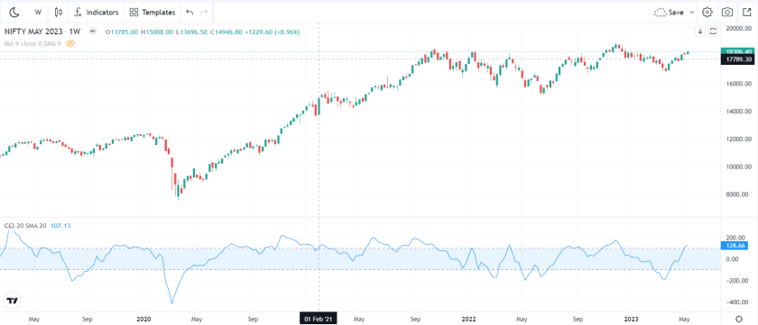

CCI or Commodity Channel Index is a leading technical indicator. Though the name starts with the word commodity, it has no direct relation with commodity trading. Rather this indicator is a very useful indicator for the trading of all assets/ stocks.

1. RSI or the Relative Strength Index

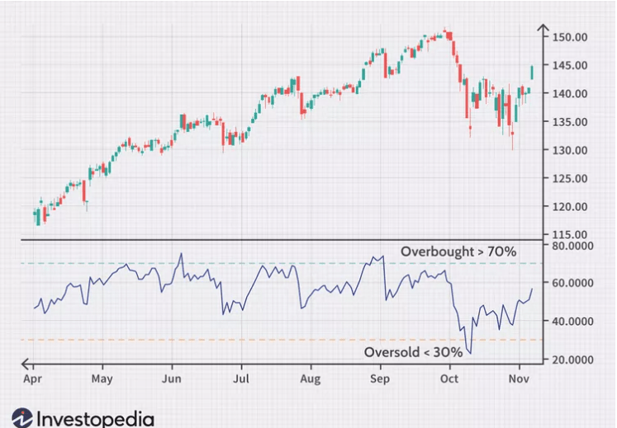

RSI or the Relative Strength Index is another highly popular leading technical indicator. RSI is a momentum indicator that shows the [overbought-oversold](https://www.stockmaniacs.net/overbought-and-oversold-meaning/) zones of price.

1. Volume

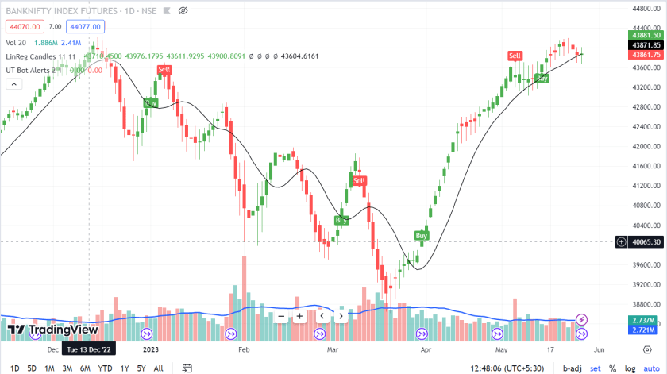

Volume is an important technical indicator. It is generally agreed that delivery with high volume indicates a surge in price. But this condition is not the only factor that controls the price direction

.

1. Lagging Indicator
2. [moving average](https://www.stockmaniacs.net/moving-average-indicator/)

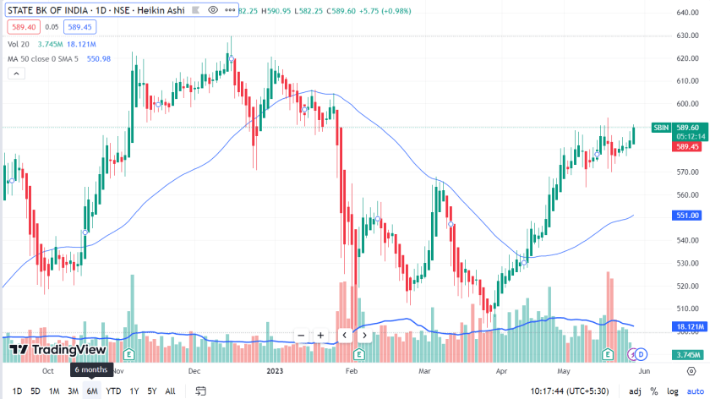

The Simple Moving Average (MA) is also known as MA. When the moving average shows the moving average of prices over every day, we call it the Daily Moving Average (DMA). MA is nothing but the average price of the stock or asset over a specific time. DMA is the daily moving average. The MA calculation counts the closing price of a stock over a specified period. The average price is of 14 periods as a standard. But we can customize it.

1. Moving average crossovers

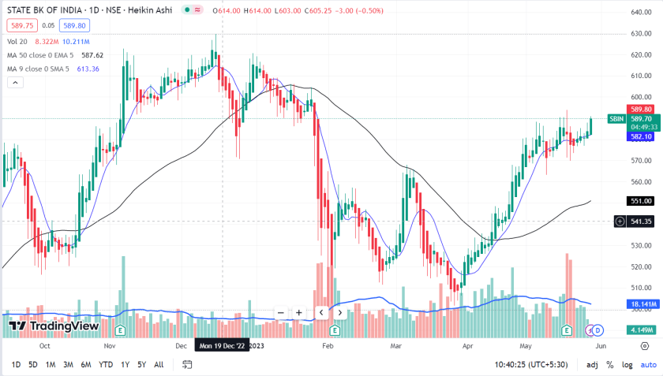

This is not an independent indicator. We consider two or more MAs or EMAs to compare the latest price trend. Traders consider 9 EMA and 50 EMA to get the latest trend. We sometimes take the crossover point of these two MAs to take buy or sell trade

1. Moving Average Convergence Divergence or MACD

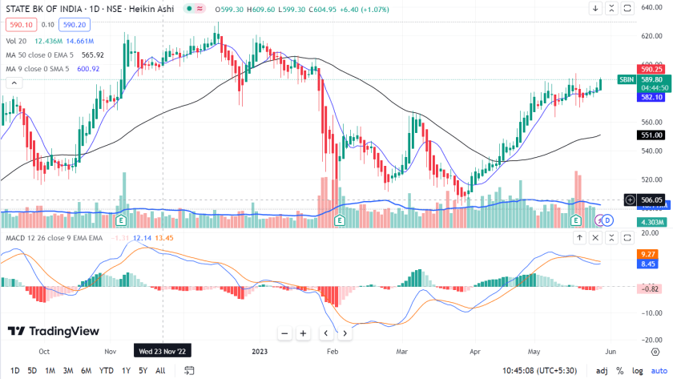

The Moving Average Convergence Divergence or MACD is a lagging indicator that uses MA to show the immediate trend. It helps the trader to take trading decisions. MACD shows momentum and trend strength which helps traders to take decisions. It uses two EMAs to plot fast and slow lines. MACD also provides a histogram to give a better view of trend duration

1. CONCLUSION

In conclusion, this comparative analysis sheds light on the efficacy of leading and lagging technical indicators in the Indian stock market context. Through meticulous examination and practical examples, this study has underscored the importance of understanding the nuances of these indicators in forecasting stock price movements. Both leading and lagging indicators exhibit strengths and weaknesses, with their utility contingent upon market conditions and investment strategies. While leading indicators offer early signals for potential trend reversals, they are prone to false positives, especially in volatile markets. On the other hand, lagging indicators provide more reliable signals by confirming established trends, albeit with a delay. The integration of multiple indicators and complementary analysis tools emerges as a prudent approach to enhance trading strategies. Ultimately, this research contributes valuable insights to traders and investors, empowering them to make informed decisions amidst the dynamic landscape of the Indian stock market.

1. FUTURE WORK
2. Algorithmic Trading and Machine Learning Integration:

Explore the integration of advanced machine learning techniques and algorithms to enhance the predictive power of technical indicators. Develop and test machine learning models that can adapt to changing market conditions and optimize trading strategies based on real-time data.

1. Dynamic Indicator Parameters:

Investigate the dynamic adjustment of indicator parameters based on market volatility, trend strength, or other relevant factors. This adaptive approach could potentially improve the robustness of indicators across various market conditions.

1. Cryptocurrency Markets Analysis:

Extend the research to analyze the effectiveness of leading and lagging indicators in cryptocurrency markets. Given the unique characteristics and volatility of cryptocurrencies, understanding how these indicators perform in this emerging market could be valuable.

1. Real-Time Monitoring and Alerts:

Develop tools for real-time monitoring of indicators and automated alert systems. This could assist traders in making timely decisions by receiving alerts for potential buy or sell signals based on the analyzed technical indicators.

1. Behavioral Finance Considerations:

Explore the impact of behavioral biases on the effectiveness of technical indicators. Investigate how investor sentiment, cognitive biases, and herd behavior influence the signals generated by leading and lagging indicators.

1. Intraday Trading Analysis:

Narrow the focus to intraday trading and assess the performance of technical indicators on shorter timeframes. Understand how well these indicators adapt to the rapid price movements and short-term trends characteristic of intraday trading.

1. Portfolio Management Strategies:

Extend the research to evaluate how the combination of leading and lagging indicators can contribute to effective portfolio management. Assess the diversification benefits and risk-adjusted returns achieved by incorporating a variety of technical indicators.

1. Cross-Market Comparison:

Conduct a comparative analysis of leading and lagging indicators across different global markets. Explore whether the effectiveness of these indicators varies based on regional economic conditions, market structures, or regulatory environments.

1. Interactive User Interfaces:

Develop user-friendly interfaces or tools that allow traders and investors to interactively explore and customize the application of technical indicators. This could facilitate a more personalized approach to technical analysis.

ACKNOWLEDGMENT

The successful realization of the "Comparative Analysis of Leading and Lagging Technical Indicators in the Indian Stock Market" project owes much to the generous support and collaboration of numerous individuals and institutions. We express profound gratitude to our sponsors whose visionary support provided the foundational resources and encouragement essential for this research's development, contributing significantly to shaping its vision and methodology. Special appreciation is extended to Mrs. Pranjali Kasture for her invaluable guidance, mentorship, and expertise, which played a pivotal role in steering the research towards success. Her insightful feedback and unwavering encouragement were instrumental in refining our approach and ensuring the quality of our analysis. Furthermore, we acknowledge Thakur College of Engineering and Technology for providing the conducive academic environment and resources that facilitated the research and development process, reflecting the institution's commitment to fostering excellence in education and research. Lastly, we extend our thanks to all individuals who directly or indirectly contributed to this project's realization, as your support has been invaluable in bringing this research to fruition.

REFERENCES

[1] Gupta, R., et al. (2019). A Comparative Analysis of Moving Averages and Relative Strength Index (RSI) in Stock Market Trading. International Journal of Management, Technology, and Engineering, 9(1), 2229-3191.

[2] Sharma, S., & Jain, R. (2018). Predictive Power of Stochastic Oscillator in Indian Stock Market. International Journal of Recent Technology and Engineering, 8(2), 209-213.

[3] Goyal, N., & Arora, A. (2020). Predicting Stock Prices using Machine Learning Techniques. International Journal of Recent Technology and Engineering, 8(4), 8235-8241.

[4] Agarwal, S., et al. (2017). Predicting Stock Prices using Machine Learning Techniques. International Journal of Computer Applications, 160(2), 19-24.

[5] Mishra, S., et al. (2016). A Comparative Study of Technical Indicators in Stock Market for Generating Trading Signals. International Journal of Scientific Research in Computer Science, Engineering, and Information Technology, 2(5), 27-32.

[6] Singh, R., & Sharma, S. (2017). A Comparative Study of Technical Indicators in Stock Market for Generating Trading Signals. International Journal of Engineering Science, 6(11), 54-58.